|  |
| --- |
| Data Science final project |
| Priteesh Hanumante |
|  |
| Usage of data to analyze a new venue location in the city of Madrid |
|  |

Data Science final project

Priteesh Hanumante

# **Business understanding**

• • •

* This final project aims to solve the problem of opening a new restaurant in the city of Madrid, Spain.
* Currently, there is no specific type of restaurant, as first we would like to know what types of restaurants can be encountered in the different neighbourhoods of the city.

# **Data requirements**

* The data to take a decision on what type of restaurant and what neighbourhood to choose will be a database generated from the information available at Foursquare.
* Once the data is obtained, a map will be generated representing the neighbourhoods of Madrid and a study on the density of restaurants will be conducted.

# **Data collection**

* An excel table was made with the districts and neighbourhoods. Added to that, each latitude and longitude.
* 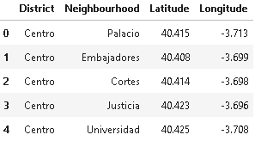
* Subsequently, using Foursquare, the information of the venues from each neighbourhood was obtained.
* Basic information such as name, category and coordinates was added.
* 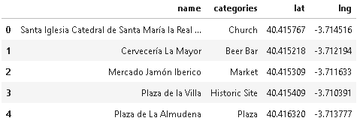

# **Data cleaning**

* Foursquare provided with all the venues of each neighbourhood. For this data analysis, only venues such as restaurants, cafes, bars and similar will be part of the dataset.
* Therefore, venues such as churches, parks, theatres, etc. were deleted.
* 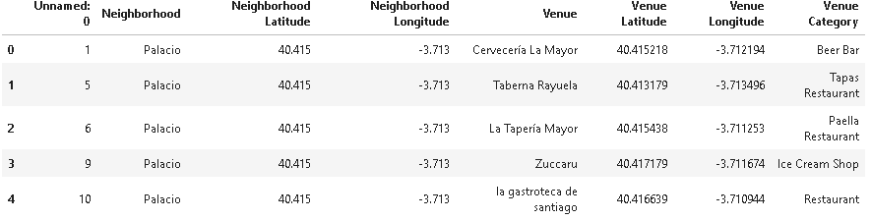

# **Data preparation**

* The are 110 categories of venues after the data cleaning.
* To make the analysis simpler, the venue categories will be classified in subgroups.

# **Further Preparation**

* However, the subcategories of international food are yet not specific enough. As for example, Mexican food is different from Argentinian. Or, Italian is different to Eastern European or Slavic.
* Therefore, subsets of international food are made.

# **Data Visualization**

* Once classified all venues in Madrid, it is possible to visualize in a map the concentration of restaurants of a certain category.
* 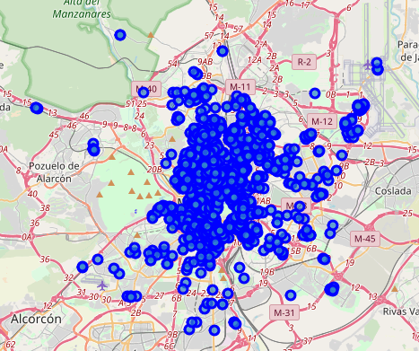

# **Map of typical Spanish venues**

* They are everywhere in the main city and in the outskirts. Its not hard to find one in the province of Madrid.

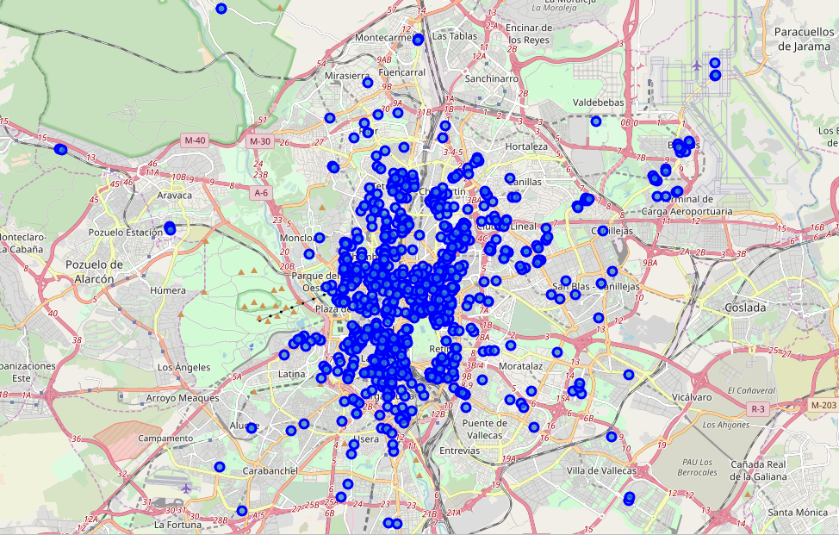

# **Map of drinking places**

* The vast majority of establishments are in the main city, on the outskirts there is a lower concentration.
* However, it its important to notice that Spanish local venues serve drinks.

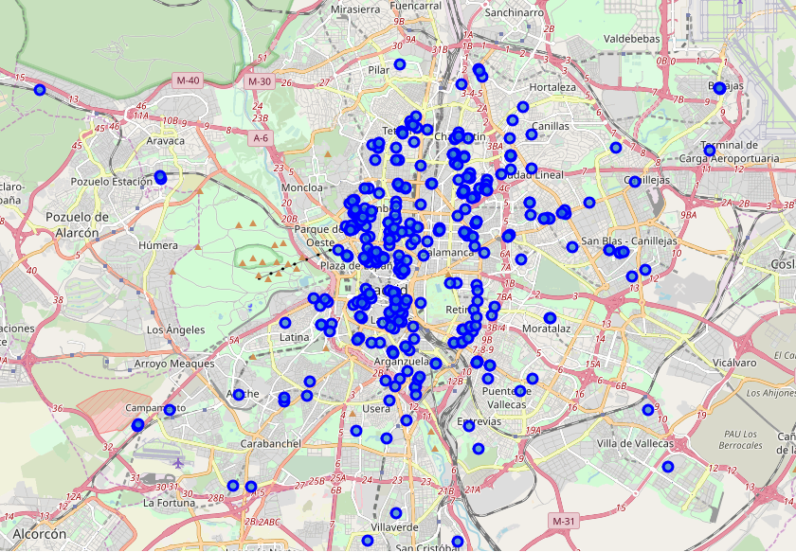

# **Map of fast food venues**

* It is evident that there is a low amount of fast food venues in the south of Madrid.

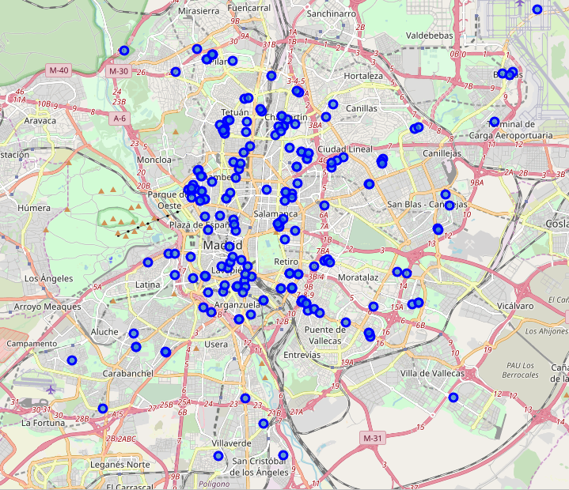

# **Special type**

* They can be found mainly in the centre and northern upstate districts of Madrid.

# **Dessert venues**

* It is evident that they can mainly be found in the city centre.

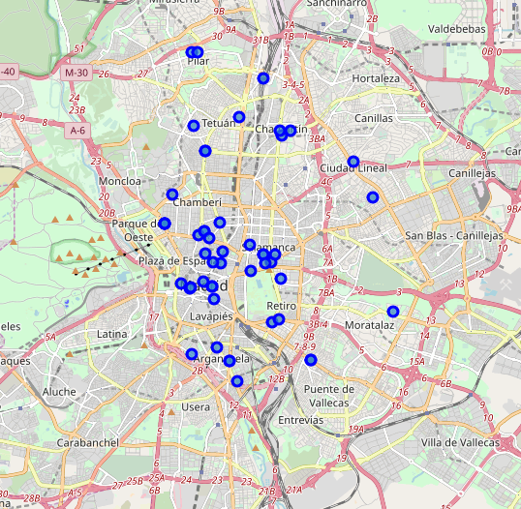

# Latino type venues

* Can be found mainly in the city centre as well as the upscale districts.

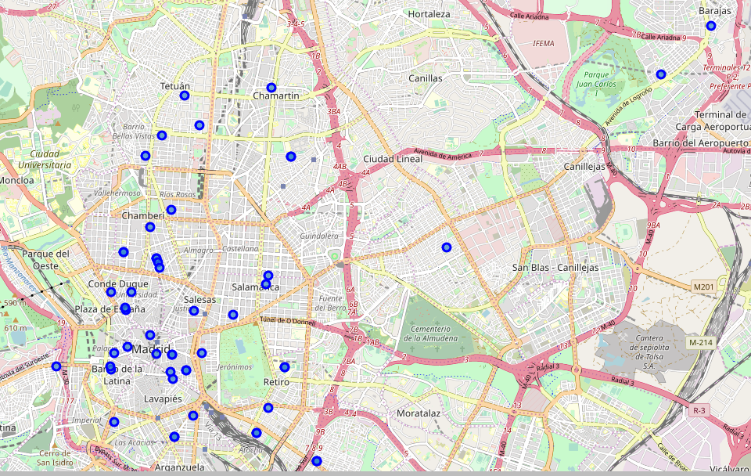

# **Asian establishments**

* Can be found generally in the city centre and upstate districts.
* Opening a venue in the outskirts and suburbs could be a good opportunity.

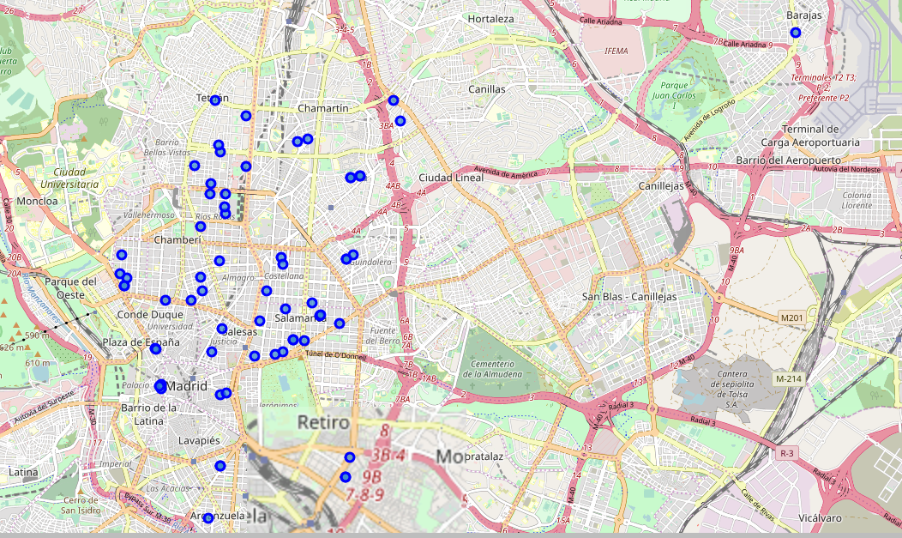

# **American Style Venues**

* They are only concentrated in upstate districts. However, they seem to be very stretched out.

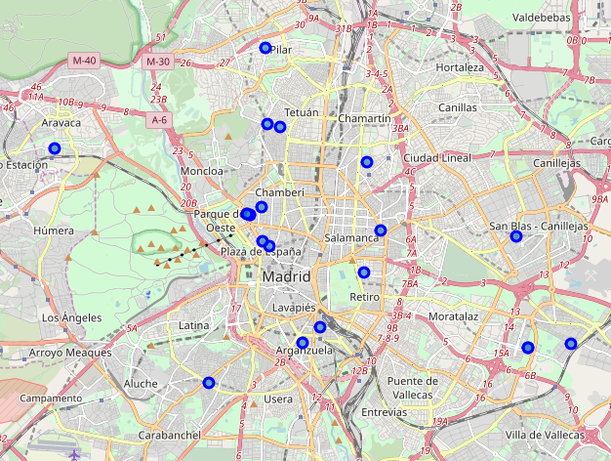

# **European establishments**

* Concentrated in the city centre and upstate distrcits.
* It is hard to find one in the south of the city, enabling a business opportunity.

# **African venues**

* Unfortunately, only two venues can be found in all the city.
* This shows a great business opportunity to open one in the city centre, as there is no competition from other African style restaurants.

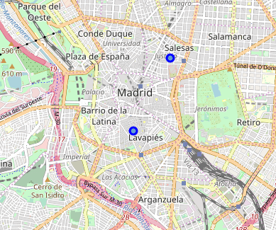

# **Conclusion**

* Opening a typical Spanish venue has a lot of competition, a great key difference would be essential to be competitive.
* Fast food is common; however, location is essential.
* Asian style gives a good opportunity, nevertheless, as fast food, location is key.
* Latino and American restaurants offer a better opportunity in contrast to Asian cuisine, as they are sparsely separated through the city. A good location would be on the north and east side of the city.